**LAFDS Session 3&4 Homework**

**Full Name: _____________________________**

**Group No.: ____**

**Lecturer Name: ____________________**

**Submission date: _/_/__ Grade: __/40**

## Please write down all the steps not the final answer only

## Questions (25 points):

1. (5 points) Find the determinant of the matrix M :

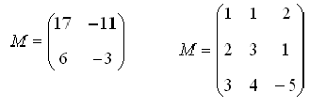

1. (5 points) Find the inverse matrix A-1 to the matrix A :

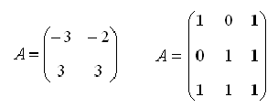

1. (5 points) Find the rank of the matrix M

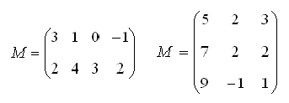

1. (15 points) Find the solution set of the following systems of linear equations.
2. 
3. 
4. 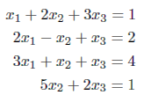
5. (5 points)

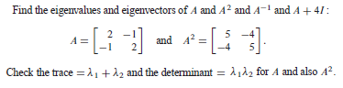

(The trace is the sum of the main diagonal elements. It is also the sum of the eigenvalues. (the trace is invariant with respect to change in basis).

## Practice with Code (15 points):

1. (5 point) Calculating the inverse of a 2x2 matrix without using numpy

* Code a function to calculate the determinant of 2x2 matrix
* Code a function that interchange the diagonal elements of a 2x2 matrix and inverse the sign of the off diagonal elements
* Code a function to compute the inverse of 2x2 matrix based on the two previous functions if it exists

1. (10 point) Coding a Python code to inverse a 3x3 matrix in order to solve a linear system (no numpy.linalg.inv allowed) with 3 constraints and 3 variables:

* Coding a function that checks if a 3x3 matrix is invertible
* Coding a function that generates the transpose of a 3x3 matrix
* Coding a function that generates the matrix of minors of a 3x3 matrix
* Coding a function that generates the matrix of cofactors of a 3x3 matrix
* Coding a function that generates the inverse of a 3x3 matrix if it exists

## Reading homework:

* **Determinants:** <https://www.youtube.com/watch?v=Ip3X9LOh2dk> (video 3blue1brown)
  + <https://medium.com/sho-jp/linear-algebra-101-part-5-determinants-b54f990782cc>
  + <https://www.mathsisfun.com/algebra/matrix-determinant.html>
  + <https://medium.com/linear-algebra/part-20-determinants-e4b2fbcce883>
  + <https://medium.com/linear-algebra/part-21-properties-of-determinants-1af8a231fd2b?source=---------0----------------------->
* **Inverse of a matrix**
  + <https://www.mathsisfun.com/algebra/matrix-inverse.html>
  + <https://www.mathsisfun.com/algebra/matrix-inverse-minors-cofactors-adjugate.html>
* **Some Applications of the Eigenvalues and Eigenvectors of a square matrix:**
  + A note by Michael Nasab (Lecturer at California State Polytechnic University) <https://www.cpp.edu/~manasab/eigenvalue.pdf>
* **What are Eigenvalues and Eigenvectors?**
  + <https://medium.com/fintechexplained/what-are-eigenvalues-and-eigenvectors-a-must-know-concept-for-machine-learning-80d0fd330e47>
  + <https://medium.com/sho-jp/linear-algebra-part-6-eigenvalues-and-eigenvectors-35365dc4365a>
* **Diagonalization**
  + <https://textbooks.math.gatech.edu/ila/diagonalization.html>
* **Principal component analysis (PCA)**
  + <https://towardsdatascience.com/pca-eigenvectors-and-eigenvalues-1f968bc6777a>